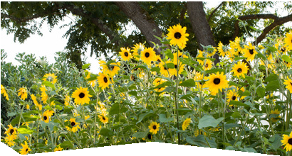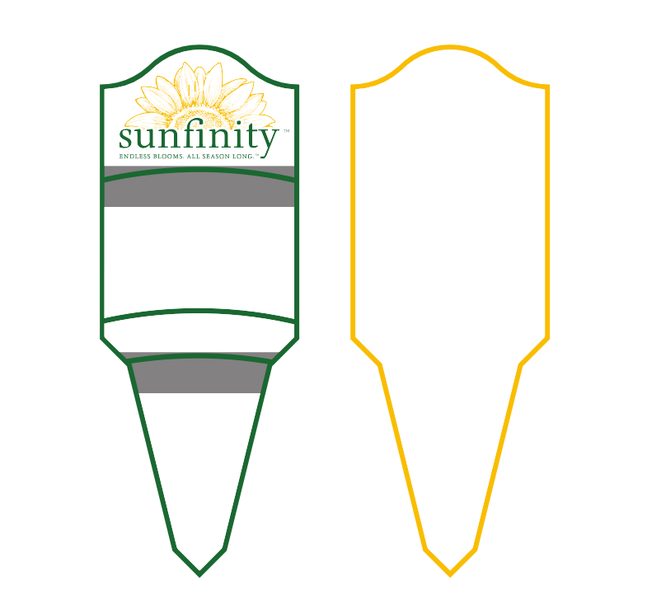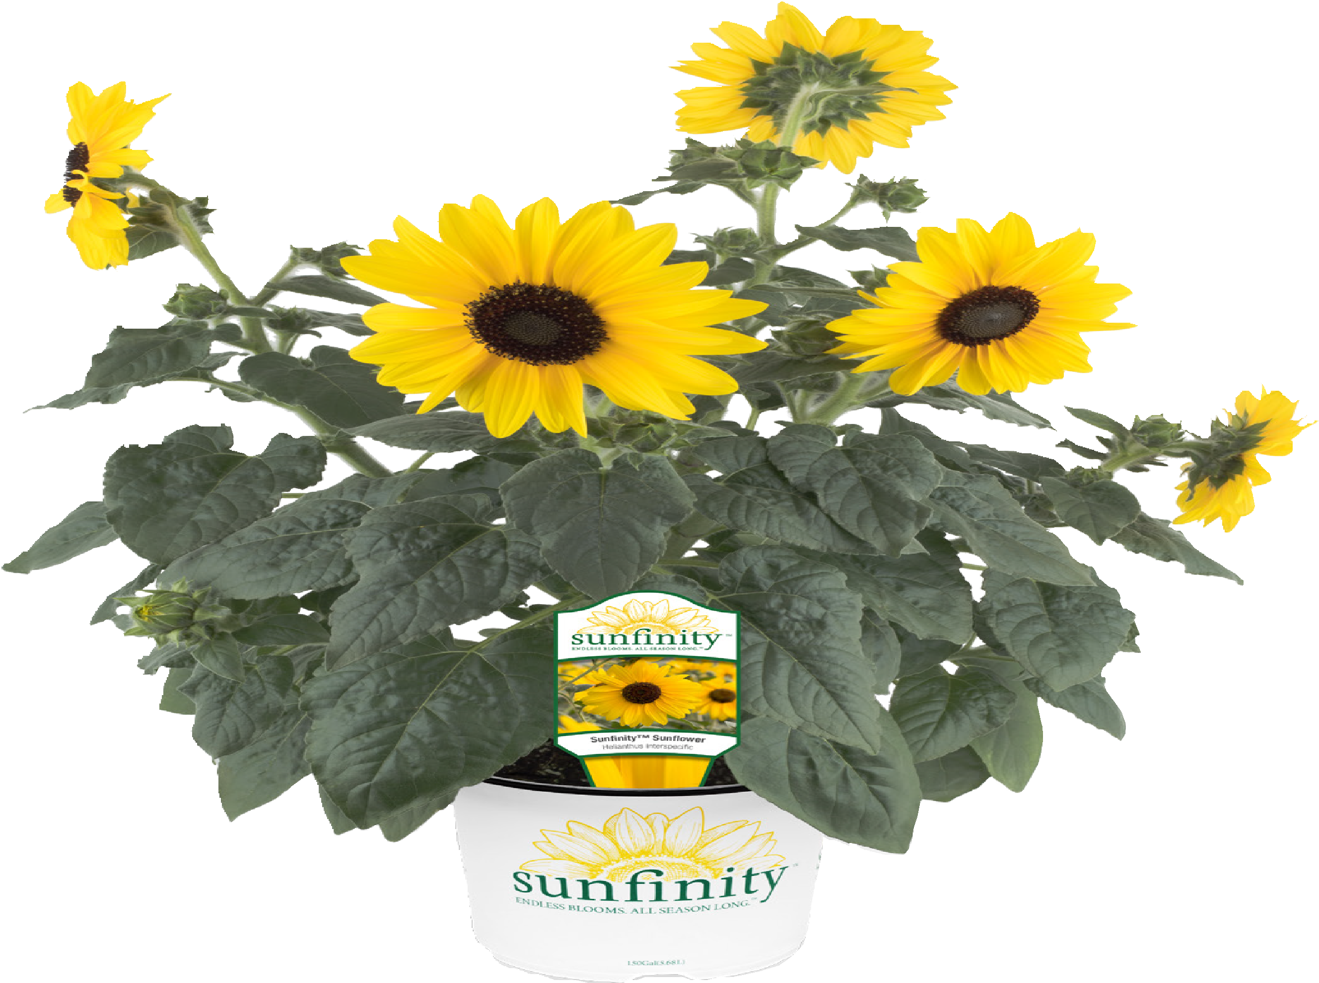
SUNFINITY BRANDED TAG AND POT
™
s i
The Next Generation of Sunfowers
Make your garden come to life with Sunfinity Sunflowers that thrive and bloom continuously all season long. Sunfinity Sunflowers have lots of blooms that can be cut and used indoors, with no mess and without damaging the outdoor plant. The outdoor plant will continue to bloom long after traditional sunflowers have bloomed and died.
Care Instructions
- Light Exposure: Sun
 Height: 36–48” | Width: 24–36”
- Water: Every other day
- Maintenance: Keep weed-free
Grower’s Informaton

© 2017 Syngenta Trademarks used herein are trademarks of a Syngenta Group Company or their
respective third party owners.
Size: 2 in x 6 in. (80% scale)
n
000.000
A0000-000 000.000

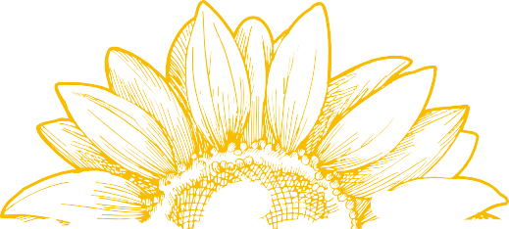

Finished Grower Branding and Contact Information

Company: | [Company Name] | Pricing: | Level #
Ordered By: | [Orderer Name] |  | Level #
PO #: | [PO Number] |  | Level #
Phone: | [+# (###) ###-####] | Order Deadline: | [Deadline]
Delivery Address: | [Address Line 1]  [Address Line 2]  [Address Line 3] | Delivery Charge: | [Delivery Charge]

Week of: | Week # | Week # | Week # | Week # | Week # | Week # | Week # | Week #
Pot Size 1
Pot Size 2
Pot Size 3
Pot Size 4

